**CSE311: Database Management System, Sec: 03**

**Project Proposal: University Academic Information System**

**Group Members......**

**Name: Al Musabbir ID: 1611158042**

**Name: MD. Ashraful Kabir ID: 1711038042**

**Name: Monjur A-Elahi Tanmoy ID: 1620587042**

**Spring’19, North South University**

**University Academic Information System**

A university has many students in undergraduate and post-graduate studies. A student has id, name, present address (H-no, street, city, district), permanent address (H-no, street, city, district), type (resident/non-resident), credit-earned, CGPA, date of enrolment. There are many departments in the university. A student must be assigned in one department but a department have many students. Any new student applying for admission into the university must submit his detailed information as per the student information form (Attachment 1).

A department offers many courses and a student can take many courses. A course can also be taken by many students. For each course and student pair, you have to keep information about semester, year and grade-point. For each course, there are many sections. A student can enroll for a course in only one section. A section has section id, semester and year.

There are many teachers in a department. A teacher has id, name, room no, mobile, email. A teacher has office hours as day, time from, time to. Office hours can be one or more days in a week. A teacher teaches many courses and a course is taught by many teachers. A teacher can teach many sections of a course but a section can have only one teacher. Teacher information can be submitted to the system as per attachment 2.

There are many rooms in the university located in different buildings. A room has an id, type, status and floor. Classes are held for different sections in different rooms in different time slots. A time slot has id, from-time and to-time. A room is assigned to a section of a course in a semester. A room can be booked by a faculty for a time-slot if the status of the room is vacant.

At the beginning of the semester, the status of all rooms in vacant. As per the number of courses and sections offered in a semester, the status of the rooms are changed as occupied. A room is allocated to multiple sections in different semesters for different courses.

Teachers submit grades at the end of each semester. The grade submission is given as per attachment 3. Teachers can submit grades only for those courses taken by that teacher.

Task 1: Design ERD

Task 2: Transform the ERD into relational schema

Task 3: Create tables using SQL DDL

Task 4: Design and implement all of the interfaces mentioned in text and all forms for data entry into the system.

Task 5: Sample data entry and showing all of the functionality of the system.

Attachment 1

Student Application Form

First Name: ____________ Middle Name __________________ Last Name _____________

Father’s Name __________________ Mother,s Name _________________________

Present Address

House No. ___________ Location _________________ Village/Street _______________

Thana ______________ District ________________ Post code ______________

Permanent Address

House No. ___________ Location _________________ Village/Street _______________

Thana ______________ District ________________ Post code ______________

Date of Birth __________ (DD-MM-YYYY)

Educational Qualifications

|  |  |  |  |  |
| --- | --- | --- | --- | --- |
| Name of degree | Institute | Board | Year | Result |
| JSC/JDC |  |  |  |  |
| SSC |  |  |  |  |
| HSC |  |  |  |  |

Attachment 2

Teacher Information Form

First Name: ____________ Middle Name __________________ Last Name _____________

Father’s Name __________________ Mother,s Name _________________________

Present Address

House No. ___________ Location _________________ Village/Street _______________

Thana ______________ District ________________ Post code ______________

Permanent Address

House No. ___________ Location _________________ Village/Street _______________

Thana ______________ District ________________ Post code ______________

Date of Birth __________ (DD-MM-YYYY)

Educational Qualifications (Before graduation)

|  |  |  |  |  |
| --- | --- | --- | --- | --- |
| Name of degree | Institute | Board | Year | Result |
| JSC/JDC |  |  |  |  |
| SSC |  |  |  |  |
| HSC |  |  |  |  |

Educational Qualifications (Graduation and after Graduation)

|  |  |  |  |  |  |
| --- | --- | --- | --- | --- | --- |
| Name of degree | Major | Minor | Institute | Year | Result |
| B. Sc. |  |  |  |  |  |
| M. Sc. |  |  |  |  |  |
| Ph. D. |  |  |  |  |  |

Experience

|  |  |  |  |  |
| --- | --- | --- | --- | --- |
| Position | Organization | Time from | Time to | Remarks |
| Lecturer |  |  |  |  |
| Asst. Professor |  |  |  |  |
| Associate Professor |  |  |  |  |
| Professor |  |  |  |  |
| Post-Doc |  |  |  |  |

Research Publication

|  |  |  |  |  |
| --- | --- | --- | --- | --- |
| List of Authors | Type (Journal/Conference) | Pub-Info (Title, Volume Number, Issue Number for journal), Title, venue, date for conference) | Page number | Year |
|  |  |  |  |  |
|  |  |  |  |  |
|  |  |  |  |  |

Graduate work

|  |  |  |  |  |
| --- | --- | --- | --- | --- |
| Degree (MSc, PhD, Diploma) | Thesis title | Research area | Month | Year |
|  |  |  |  |  |
|  |  |  |  |  |

Attachment 3

Grade Submission by Teachers Form

Course Id: _____________ Semester ___________ Year ______________

|  |  |  |
| --- | --- | --- |
| Student Id | Name | Letter Grade |
|  |  |  |
|  |  |  |
|  |  |  |

We have used HTML, CSS, JavaScript, Bootstrap, PHP to implement this project.

**Entity Relationship Diagram**

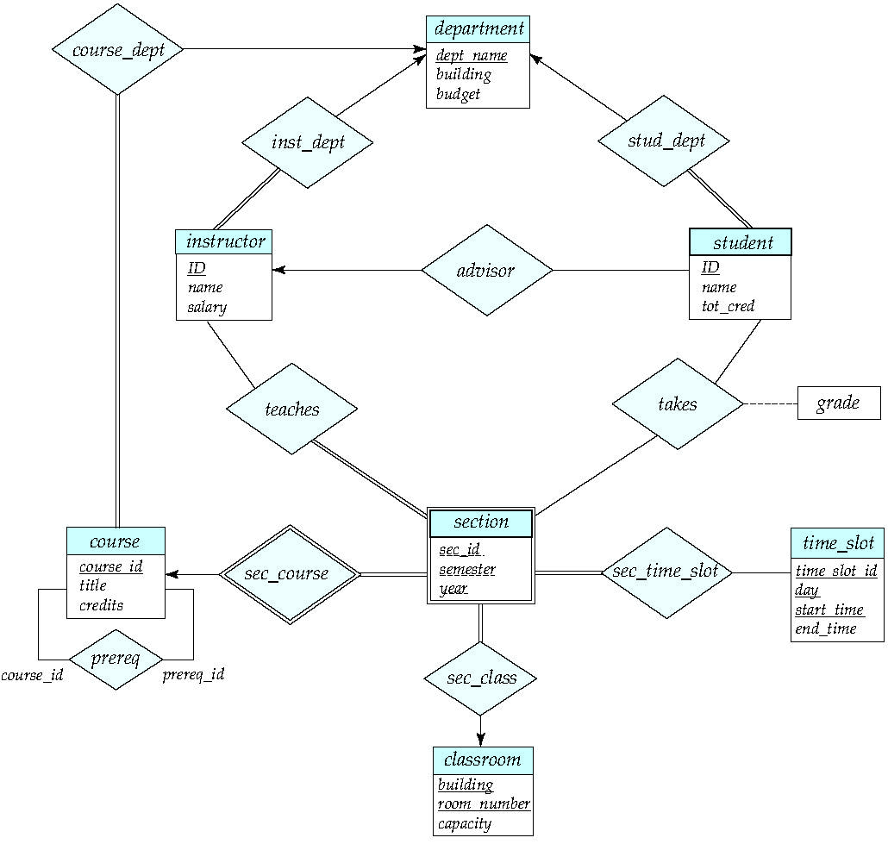

**Schemas**

Course(C_id, Course_Title, Credit_hour, Semester, Faculty, Dept)

Prerequisite(C_id, Pre_Id)

Section(C_id, sec_id, semester, year, room_no, Building, Time_Slot_id, capacity)

Time_slot(Time_slot_id, day, start_time, End_Time)

Department(D_id, DName, location, Chair, budget)

Instructor(TID, TName, Salary, Dept)

Teaches(T_id, C_id, Sec_id, semester, year)

Student(S_ID, First_Name, Middle_Name, Last_Name, Mother_Name, Father_Name, DOB, Pr_house_no, Pr_Location, Pr_Locaton, Pr_Thana, Pr_Village, Pr_District, Pr_Post_code, Pa_house_no, Pa_location, Pa_village, Pa_thana, Pa_district, Pa_post_code, JSC_Institute, JSC_Board, JSC_Year, JSC_Result, SSC_Institute, SSC_Board, SSC_Year, SSC_Result, HSC_Institute, HSC_Board, HSC_Year, HSC_Result, Student_Status, Department)

Takes(S_id, C_id, Sec_id, Semester, Year, Grade)

Teacher(T_ID, First_name, Middle_name, Last_name, Mother_name, Father_name, DOB, Pr_house_no, Pr_location, Pr_village, Pr_Thana, Pr_District, Pr_Post_Code, Pe_house_no, Pe_location, Pe_Village, Pe_Thana, Pe_District, Pe_Post_Code, Jsc_Institute, Jsc_Board, Jsc_Year, Jsc_Result, Ssc_Institute, Ssc_Board, Ssc_Year, Ssc_Result, Hsc_Institute, Hsc_Board, Hsc_Year, Hsc_Result, BSC_major, BSC_minor, BSC_institute, BSC_year, BSC_result, MSC_major, MSC_minor, MSC_institute, MSC_year, MSC_result, PHD_major, PHD_minor, PHD_institute, PHD_year, PHD_result, Lecturer_organization, Lecturer_time_from, Lecturer_time_to, Lecturer_remarks, Assistant_professor_organization, Assistant_professor_time_from, Assistant_professor_time_to, Assistant_professor_remarks, Associate_professor_organization, Associate_professor_time_from, Associate_professor_time_to, Associate_professor_remarks, professor_organization, professor_time_from, professor_time_to, professor_remarks, post_doc_organiztion, post_doc_time_from, post_doc_time_to, post_doc_remaks, Research_Authors, Research_Type, Research_Pubinfo, Research_Page, Research_year, Graduate_Degree, Graduate_Thesis_title, Graduate_Research, Graduate_Month, Graduate_Year)